* [Retrieve the start times of members' bookings](https://pgexercises.com/questions/joins/simplejoin.html)

select b.starttime from cd.bookings b

inner join cd.members m on m.memid = b.memid

where m.firstname='David' and m.surname='Farrell';

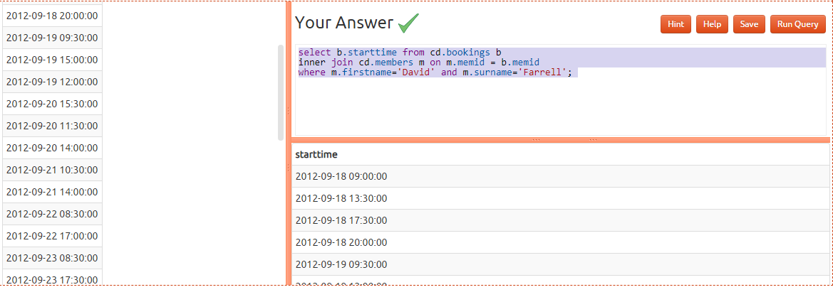

* [Work out the start times of bookings for tennis courts](https://pgexercises.com/questions/joins/simplejoin2.html)

select b.starttime as start, f.name as name from cd.facilities f

inner join cd.bookings b on f.facid = b.facid

where

(f.name = 'Tennis Court 2' or f.name = 'Tennis Court 1') and

b.starttime >= '2012-09-21' and

b.starttime < '2012-09-22'

order by b.starttime;

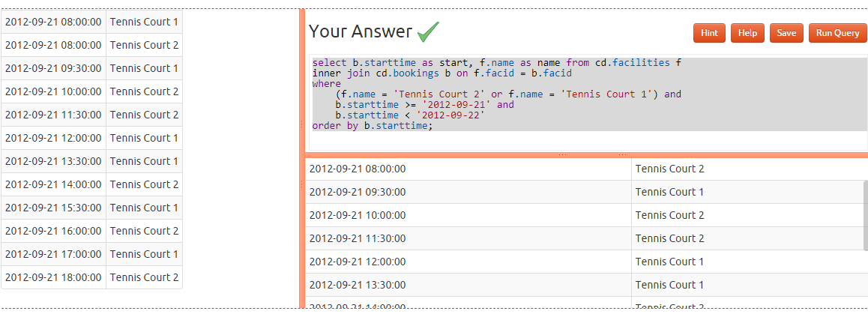

* [Produce a list of all members who have recommended another member](https://pgexercises.com/questions/joins/self.html)

select distinct recs.firstname as firstname, recs.surname as surname from cd.members mems

inner join cd.members recs on recs.memid = mems.recommendedby order by surname, firstname; 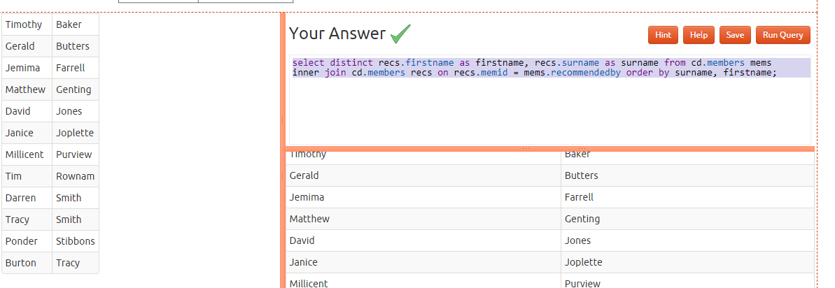

* [Produce a list of all members, along with their recommender](https://pgexercises.com/questions/joins/self2.html)

select mems.firstname as memfname, mems.surname as memsname, recs.firstname as recfname, recs.surname as recsname

from cd.members mems left outer join cd.members recs on recs.memid = mems.recommendedby

order by memsname, memfname;

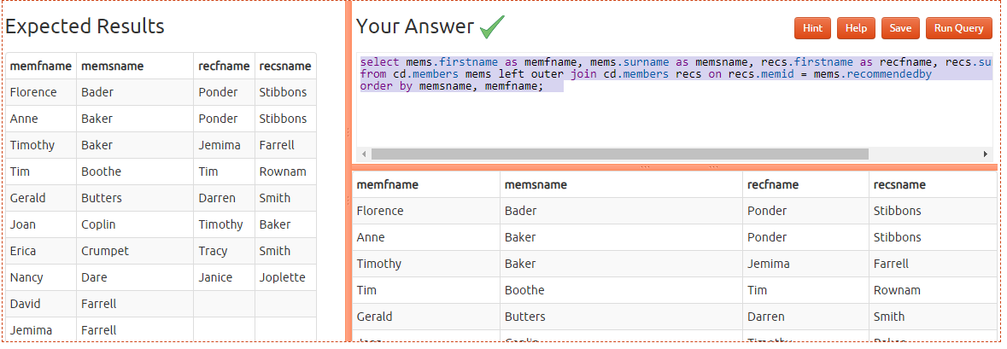

* [Produce a list of all members who have used a tennis court](https://pgexercises.com/questions/joins/threejoin.html)

select distinct mems.firstname || ' ' || mems.surname as member, facs.name as facility

from

cd.members mems

inner join cd.bookings bks

on mems.memid = bks.memid

inner join cd.facilities facs

on bks.facid = facs.facid

where

facs.name in ('Tennis Court 2','Tennis Court 1')

order by member, facility

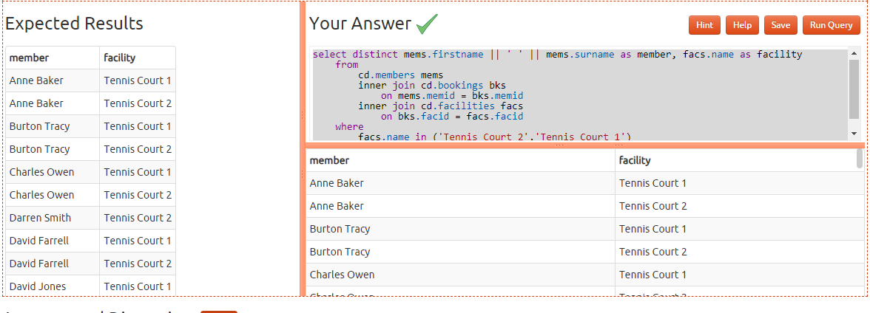

* [Produce a list of costly bookings](https://pgexercises.com/questions/joins/threejoin2.html)

select mems.firstname || ' ' || mems.surname as member,

facs.name as facility,

case

when mems.memid = 0 then

bks.slots*facs.guestcost

else

bks.slots*facs.membercost

end as cost

from

cd.members mems

inner join cd.bookings bks

on mems.memid = bks.memid

inner join cd.facilities facs

on bks.facid = facs.facid

where

bks.starttime >= '2012-09-14' and

bks.starttime < '2012-09-15' and (

(mems.memid = 0 and bks.slots*facs.guestcost > 30) or

(mems.memid != 0 and bks.slots*facs.membercost > 30)

)

order by cost desc;

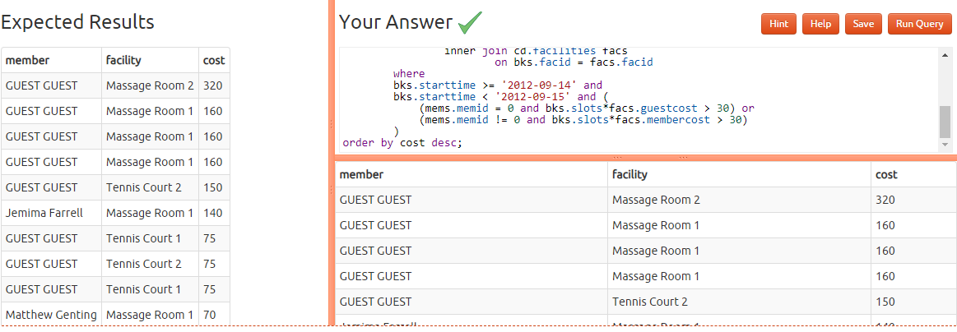

* [Produce a list of all members, along with their recommender, using no joins.](https://pgexercises.com/questions/joins/sub.html)

select distinct

mems.firstname || ' ' || mems.surname as member,

(select recs.firstname || ' ' || recs.surname

from cd.members recs

where recs.memid = mems.recommendedby) as recommender

from

cd.members mems

order by

member; 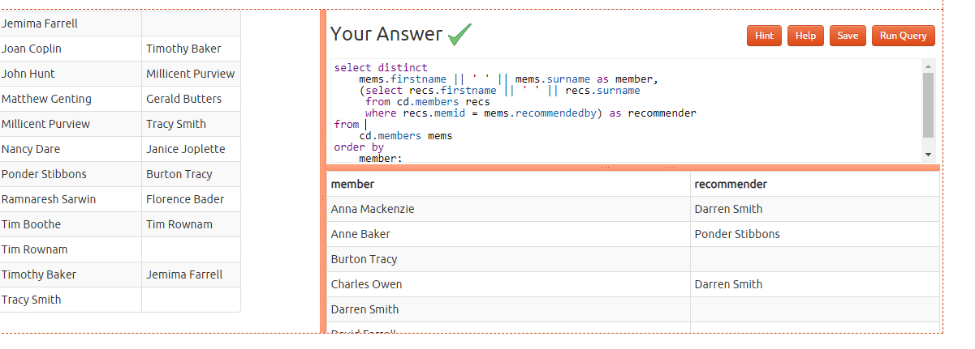

* [Produce a list of costly bookings, using a subquery](https://pgexercises.com/questions/joins/tjsub.html)

SELECT member, facility, cost

FROM (

SELECT

mems.firstname || ' ' || mems.surname AS member,

facs.name AS facility,

CASE

WHEN mems.memid = 0 THEN bks.slots * facs.guestcost

ELSE bks.slots * facs.membercost

END AS cost

FROM

cd.members mems

INNER JOIN

cd.bookings bks ON mems.memid = bks.memid

INNER JOIN

cd.facilities facs ON bks.facid = facs.facid

WHERE

bks.starttime >= '2012-09-14' AND bks.starttime < '2012-09-15'

) AS bookings

WHERE

cost > 30

ORDER BY

cost DESC;

